**A Guide to Log Cabin Heating and Cooling**

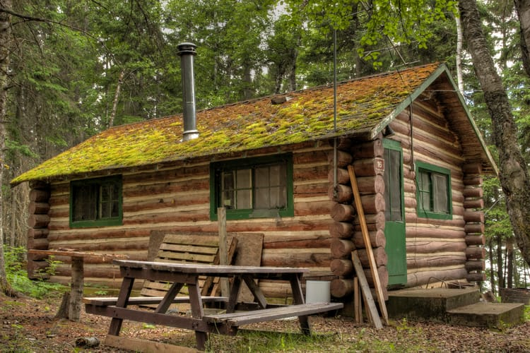

Do you have a cozy cabin home off the beaten path? Whether a vacation getaway or a main residence, log cabins have a rustic atmosphere that many enjoy. Aside from a roaring fire in the hearth, what solutions are available for log cabin heating and cooling? HVAC.com shares log cabin heating and cooling tips to keep your log home comfortable throughout the year.

**Cabin Heating and Cooling Needs**

Some log cabins need complete heating and cooling systems, while others get by with space heating in specific areas. When choosing log cabin HVAC solutions, think about how you use your log home and how often, as well as the size of your structure.

For log homes that are spacious and used as a year-round residence may use a forced air system just like a conventional home. Cabins that are smaller and only occupied occasionally may benefit from smaller capacity options that offer heating and cooling directly where needed, when needed.

**Log Cabin Heating and Cooling Systems: Under Construction**

If you’re building a new log home, you have the opportunity to include a duct system that will accommodate a forced air heating and cooling system. A new furnace, heat pump, or air conditioner will be properly sized for the cabin and the duct system constructed to meet the needs of the log cabin HVAC equipment.

Another option many cabin owners love is in-floor [radiant heating systems](https://www.energy.gov/energysaver/home-heating-systems/radiant-heating" \t "/Users/macbookpro/Documents\\x/_blank). Radiant heating systems utilize a network of fluid-filled piping below the floor to heat living areas. An added benefit of this option is warm flooring, which is very nice in mountain getaways and cabins in colder climates.

Before choosing a log cabin HVAC system, consider the fuel source available. Does your cabin have utility access? Are you going off the grid? Propane, geothermal, and solar heating and cooling systems may be preferred in remote areas. [Geothermal systems](https://www.energy.gov/science-innovation/energy-sources/renewable-energy/geothermal" \t "/Users/macbookpro/Documents\\x/_blank) can also offer hot water for use in the cabin.

**Log Cabin Heating and Cooling for Existing Homes**

If your log cabin does not have ductwork and you don’t want to install a duct system, there are energy efficient options available for both heating and cooling. A [ductless mini-split system](https://www.hvac.com/blog/ductless-heat-pump-installation-cost/) is an option for both whole home heating and cooling, as well as adding heating and cooling to just a few areas. These systems use air handlers directly installed in the areas they serve, which are connected to an exterior heat pump or air conditioner. One system can support multiple zones, serving many areas of your cabin.

Direct-vent wall furnaces are a type of standalone heating system that can be installed to serve smaller cabins. They deliver heat directly to the area in which they are installed. Gas or electric models are available, and these units offer numerous safety and comfort features to protect your cabin and your comfort.

[High velocity](https://www.hvac.com/blog/the-best-way-to-heat-cool-old-houses/) forced air systems are a ducted option, but the ductwork they use is much smaller than the ductwork used in a conventional forced air system. This may be a more feasible option for heating your log cabin if the space cannot accommodate larger ducts. High velocity log cabin HVAC systems are extremely quiet and won’t disturb the peace of your rustic getaway home.

Another option for log cabin heating and cooling is to use portable heaters and air conditioners. This may be your preferred option in a smaller cabin that is not frequently occupied. Portable and [window air conditioners](https://www.hvac.com/blog/how-to-install-a-window-air-conditioner-10-steps/) deliver cooling into the space which they are installed and varying capacities are available.

[Portable heaters](https://www.hvac.com/blog/space-heaters-safety-energy-efficiency-faqs-2/) deliver warmth directly into the room they are installed. New portable heating units include safety features to lower the risk of injury and fire. Many stylish models are available to mesh with the décor of your log cabin.

From:<https://www.hvac.com/blog/a-guide-to-log-cabin-heating-and-cooling/>